|  |
| --- |
|  |
| CSE5 ITP Application Development |
| Project Plan  Project Title:  Waste Management – Bin Monitoring System |
|  |
|  |
|  |

|  |
| --- |
|  |

1. **Table of Contents**

1 Overview 3

1.1 Project Objectives 4

1.2 Project Constraints 4

1.3 Project Risks 4

2 Proposed Solution 5

2.1 Business Requirements 5

2.2 Architecture 6

2.3 Development 6

2.4 Testing 6

2.5 Deployment 8

3 Project Resources 8

3.1 Roles and Responsibilities 8

3.2 Issue Escalation 8

3.3 Project Staffing Plan 8

3.4 Project Materials 8

4 Project Approach 9

4.1 Development Model 9

4.2 Configuration Management 9

4.3 Communication Management 10

4.4 Change Management 10

4.5 Testing 10

4.6 Documentation 10

5 Estimate 11

6 Schedule 11

# **Overview**

We have public services and waste management organisations that have been around for a long duration, they have not changed much in terms of the operation efficiency—until the last few years.

There are two innovative functions of smart waste management that have been developed recently: operational efficiency and waste reduction.

**Need for project**

Smart bins provide data for councils and businesses to maximise efficiencies and improve public health. They could also be one of the keys to building a smart city. The sanitation specialists must still physically go to the dumpster to check trash levels and thus reduces the efficiency and thereby increasing the cost.

**Challenges**

* The time duration to implement the system could prove to be challenging as learning phase for these technologies is steep.
* As mentioned earlier the learning phase for our team to adapt to this would be a healthy challenge. It requires us to learn technology and implement in short duration.
* Training for this project has been planned really well. We have subscribed to top-notch course on udemy and have guidance from technology experts.

**Opportunities**

Such an intelligent system provides various benefits to the society and the organizations.

* Both private and public waste management services can benefit from smart bins. For a small very small cost invested in a sensor technology, they can increase your operational efficiency.
* Clearly if implemented well this technology can reduce the cost for the organization in the long term. As it helps to make process efficient and thus reducing cost overheads.

## Project Objectives

This section should specifically list project objectives. These are the criteria which will be used to measure project success. For example:

* Complete application implementation by the end of week 12 of the semester 2(year 2018).
* The application needs to display a map of the town council area (zoomable)
* Displays clusters of bins (and their percentage average capacity wherein zooming on clusters will show sub-clusters (and their percentage average capacity) and further zooming will show individual bins (and their percentage capacity)
* The system allows a group of users to set a threshold value for a bin capacity and the system notifies particular group of users when a bin has reached a certain level.

## Project Constraints

The system has various constraints to be successful.

1. Technologies used in developing the system have been identified to be Angular 6, NodeJS and MongoDB.
2. The scope of the system is limited to a council level for initial release and have tendency to be expanded in later releases.
3. Time frame to complete the project has been decided to be 12 weeks.
4. The hardware is beyond the scope of the project. It has been developed and the application needs to adapt to the data provided by it.

## Project Risks

We have identified below possible risks that could affect the completion or the correct implementation of the project

1. Time frame: The major challenge for this project is to complete it within the given duration of 12 weeks.

* Risk Probability -- We have estimated occurring of exceeding the time frame to be very unlikely.
* Risk Impact -- The impact would be significant as it will lead to an unfinished project.
* Risk Mitigation -- There has been continuous project progress check placed to keep track of the progress. Every week we organise a progress meeting and try to over some things which are slowing the progress.

# **Proposed Solution**

Provide an executive summary of the proposed solution here. Documenting the proposed solution is straightforward if you have created a deliverable oriented Work Breakdown Structure (WBS). A sample application development WBS is provided as a separate document.

Not sure where to get wbs

## Business Requirements

To gather requirements and understanding then clearly we have proposed various effective ways such as evaluating existing process, Interview with clients and studying already existing similar system.

1. **Interview with the client:**

There was a meeting session organised with the client where we have chance to understand the expectations of the clients. The discussion led to understand requirements clearly and gave our team opportunity to ask questions.

2. **Studying already developed similar application:**

We have identified various system which are similar to the project being developed by us. The idea was to understand how systems have been implemented and try to learn positives and the negatives of such systems. This helped us to avoid certain pitfall and also motivated us to improve already existing systems.

The detailed study has been mentioned in the Research document for this project.

**User Interface (UI) requirements**

User Interface of the application requires to have a Map displayed on the application where in the user can see the status of bins. Also, zooming and out would change how the information is being displayed.

UI provides easy navigation for the user to switch between various councils and move to different setting of the system.

**Define specific technology requirements**

The system needs to be developed for web platform. The client has mentioned the technologies they require the project to be developed in.

The frontend of the application is being developed in Angular 6 with designing done in bootstrap. Bootstrap provides beautiful css styles which significantly reduces development time of the application.

THe backend system will be developed in node Js while accessing and saving data to MongoDB database.

## Architecture

The following diagram clearly explains how the whole stack comes into play to support the functionalities of the system.

The client being the frontend of our system.

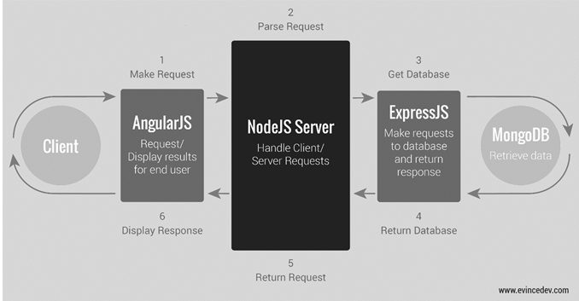

**Mockup Designs**

**Dashboard of the application:**

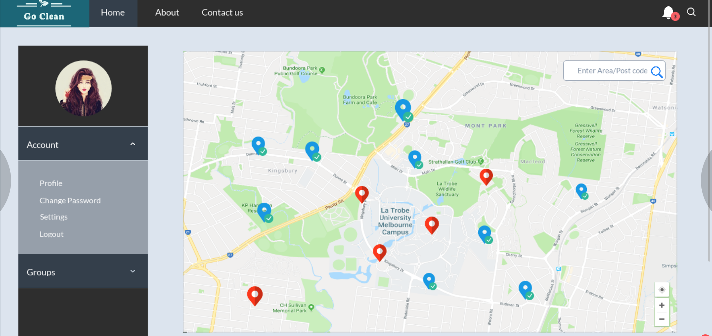

**Login screen of the screen:**

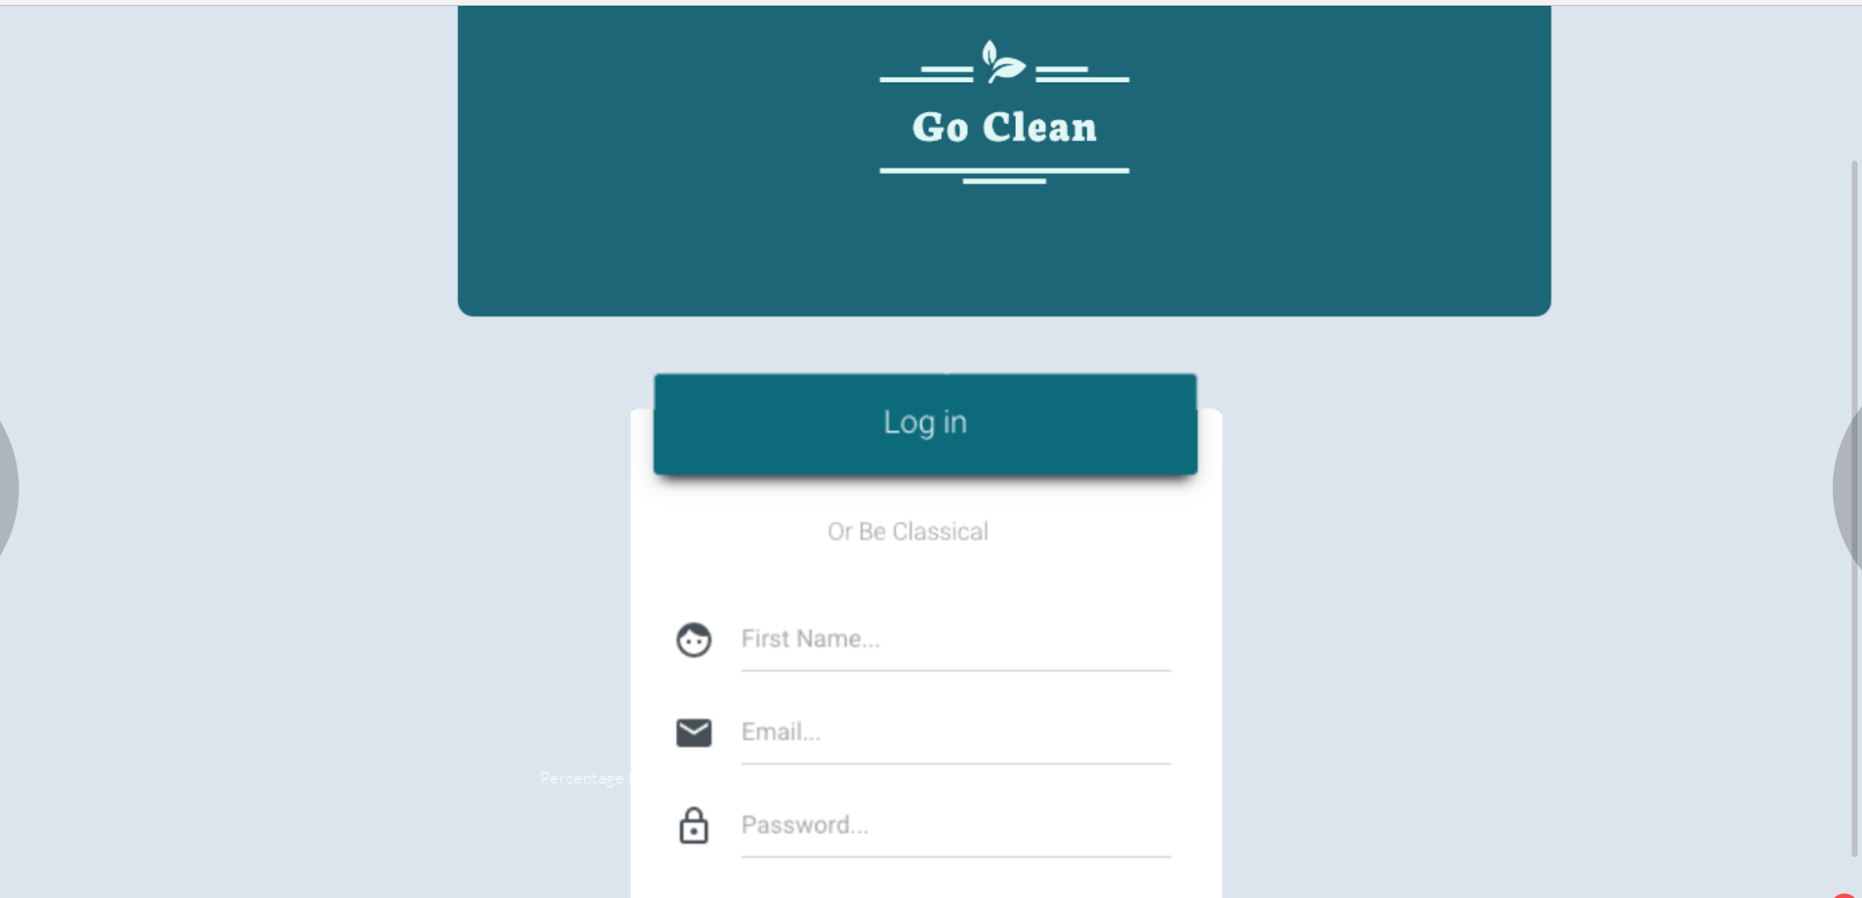

***Functional Specifications***

*Functional specifications include details regarding how the application will interface with, for example, legacy applications, provide database models and describe the relationships between the different data entities, and detail how each component of the application interacts with every other component.*

**Technical Specifications**

Technical specifications might include the following:

* Platform specifications: Application is being developed for webplatfrom with responsive design so that it could adapt to various hardwares in the market.
* Development languages: Javascript, HTML, TypeScript.

## Development

The development of the application has been divided in various sprints/phases. The tasks for each phase has been clearly identified.

* Phase 1: Design mockup website and generate UML diagram.
* Phase 2: During phase 2 we would develop a front end using bootstrap which allows to incorporate beautiful css themes into the development and then integrate leaflet component to it.
* Phase 3: Develop node js api to support calls from the front end.
* phase 4: Connect frontend to the backend api while implementing the functional requirements of the application.
* Phase 5: Testing and improvement.

## Testing

For testing the flow/system of the website. We will have peer reviews sessions in which each team member will review the work of other team member. If the reviewer feels that something needs to be improved or some part is functioning properly. It will be addressed by the respective team member who has worked on that part. Post making the improvement, there would be another session that would take place with the reviewer in which he would test the system again. These sessions will keep happening until or unless the reviewer does not show a green flag to the developer.

For tracking this, we will create the respective (Peer review) tasks in the trello that would be assigned to the person who would review it and gives his remark on the testing.

# **Project Resources**

## Roles and Responsibilities

This section of the project plan should define the various roles and responsibilities of the members of the project team. Also consider including their level of authority within their scope of responsibility (e.g. approve, support, or conduct).

Technooogy responsibility and the project manager

If staffing is subject to change, then it is important to note that here.

## Issue Escalation

Project problems need to be resolved quickly. If no resolution can be made regarding the conflict, then the project manager and the client will need a path to escalate and manage issues.

General idea. Group leader, then fo manager .(notifed to the client)

## Project Staffing Plan

The project staffing plan lists the human resources and skill sets that will be required to complete the project. An application development project will usually require: project management and planning, systems design, business and technical analysis, programming, testing, documentation, network engineering, and training. Each skill set would be listed with a detailed description of the role.

Also consider including the Resource Breakdown Structure in this section of the project plan document. This provides a basis for cost estimating and is fundamental to understanding resource allocation during the course of the project.

## Project Materials

What other materials are required to complete the project? For most application development projects, this would include hardware, physical networking infrastructure, peripherals, co-location space and licensing.

# **Project Approach**

## Development Model

This section describes the application development to be used (e.g. Microsoft Solutions Framework, rapid application development, agile development). These methodologies are complimentary to standard Project management Institute (PMI) methodologies.

agile

It is important to also describe the various stages or phases of development and detail which components or milestones will be delivered during each phase.

## Configuration Management

Configuration management plans usually define what items need to be controlled in a project – software , the various releases, hardware platforms and environments, and documents. Specifically, the following should be included:

**Components**

This section should list the specific tasks and items that need to be controlled during the course of the project. Examples may include:

* Build project baseline
* Implement code library system
* Define audit team
* Track changes in project baseline

**Tools**

This section describes the tools or techniques used in executing the configuration management processes. These may include, for example, software or code library management systems or forms and documents (e.g. change control submission, analysis and approval documentation)

**Reporting**

This section describes the reports issued by the project team and may include:

* Change History
* Release status reports
* Project Baseline analysis reports
* Audit data

**Archiving**

Define what should be archived and the length of archival time.

**Archive Control and Audit Review**

## Communication Management

A communications management plan defines how information will flow throughout the duration of the project. This can include specific requirements, such as access to a satellite phone should project members be out of cell range, as well as specific documents or correspondence formats that are required for the project. The plan should detail who is responsible for distributing what information, how often the information needs to be distributed, and to whom the information will be sent. This can include, for example, a schedule for team meetings and a list of the team members required to attend or a status report distribution list with proposed reporting format.

Slack and trello

## Change Management

All projects must deal with changes, either anticipated and planned or unexpected. A formal change management policy is designed to specifically address planned changes to evaluate their impact of the existing project schedule and budget and to provide accountability and ownership changes. Each project will have different change management requirements. Nearly all such management policies, however, need to include:

* Name of change initiator
* Documentation regarding the nature of the change
* Change impact analysis
* Change rejection / approval

The Microsoft Solutions Framework (MSF) development process integrates change management into the core development methodology. It is important that clients understand the change management process, especially considering the impact of change on the project schedule and budget.

## Testing??????

A testing plan is usually developed as part of the functional specification phase of the development project. This provides for a detailed test plan, as the analysts developers understand more about the components that will require testing. Testing should be done both in a test environment and also within the intended production environment. This will minimize issues associated with configuration variances.

This section should provide details associated with the test process: the project role (and individual, if a specific person has been identified) responsible for testing, other human resource requirements and a schedule for testing (or associated milestones).

If an application will be used to track bugs or provide testing feedback to the development and management group, then this should be documented here as well. Otherwise, feedback documentation should be provided in the project plan.

## Documentation

This section details what documentation will be delivered during both the course of the project and at project end. Clients are usually most interested in system administrator and user documented. It is important to document how the information will be provided – in electronic, physical media format or perhaps both.

Documentation is a project deliverable, just like the User Interface. Expect to provide clients with several versions for review.

# **Estimate??????**

This section should be used to detail the project’s cost estimate. There are many methods to estimating project costs. All methods require basic information relating to scope, timeframe for delivery and resources available. This estimate uses input data from the Work Breakdown Structure to create a Resource e Breakdown Structure document. It is this Resource Breakdown document which provides the basis of the cost estimating template.

manhours

# **Schedule**

The project schedule can be completed only after all project tasks have been defined and prioritized. The schedule is one of the last components of a project plan to be completed.

//deadline